Chapter 6: Testing
6.1. Validation and Verification

• V & V is a whole life-cycle process. It starts with requirements reviews and continues through design reviews and code inspections to product testing. There should be V& V activities at each stage of software process.
• Validation : Are we building the right product?
• Verification : Are we building the product right?
Within the V & V process, two techniques of system checking and analysis may be used:
Software Inspections - Analyze and check system representations such as the requirements documents, design diagrams and program source code. They may be applied at all stages of the development process. Inspections may be supplemented by some automated analysis of the source text of a system or associated documents.
Software inspections and automated analysis are static V & V techniques as they do not require the system to be executed.
Software Testing - Involves executing an implementation of the software with test data and examining the outputs of the software and its operational behaviour to check that it is performing as required. Testing is a dynamic technique of V & V because it works with an executable representation of the system.
Software Testing Procedure
• Testing procedures should be established at the start of any software project.
All testing carried out should be based on a test plan, this should detail which tests are to be carried out. For each test, the following information should be included in the test plan:
* the pre-requisites for the tests.
* the steps required to carry out the tests
* the expected results of the test.
The outcome of any tests should be recorded in a test results document that include whether the test succeeded or failed and a description of the failure.
Test results for all passes through the test plan must be recorded to allow accurate records to be kept of where problems occur and when they were identified and corrected.
Testing Process
1. Run the tests as defined by the test plan.
Note : Testing should not stop when the first problem is encountered, unless it is so severe that the rest of the tests would be meaningless. Rather all testing in the test plan should be carried out and then the errors addressed.
2. Record the outcome of each test in the test report, both success and failure should be reported. For failed tests the nature of the problem should be described in sufficient detail to allow it to be corrected and to allow analysis of the types of errors being found.
3. Correct the errors that were documented from the test run.
4. Repeat the process until no errors are identified or error rate is sufficiently low. If the error rate is low then it may be sufficient to simply re-test the failed errors. If the error rate is high then all tests should be re-run.
• Dynamic verification Concerned with exercising and observing product behaviour (testing)
– includes executing the code • Static verification Concerned with analysis of the static system representation to discover problems
– does not include execution

Dynamic and static verification

The dynamic testing process
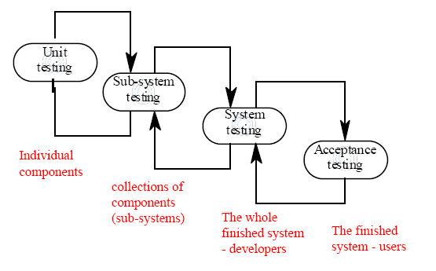

Testing in the project lifecycle
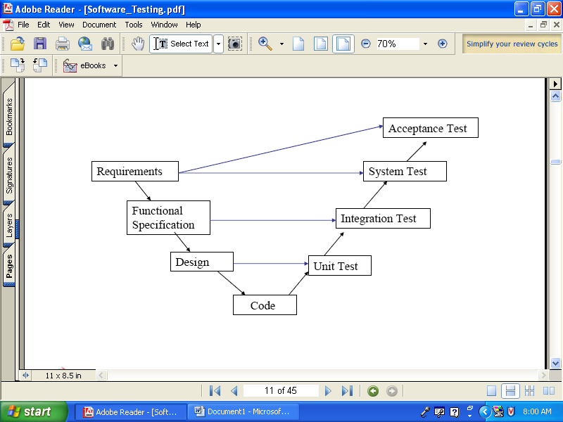

6.2.
Black-box testing
• Approach to testing where the program is considered as a ‘black-box’
• The program test cases are based on the system specification
• Inputs from test data may reveal anomalous outputs i.e. defects
• Test planning can begin early in the software process
• Main problem - selection of inputs
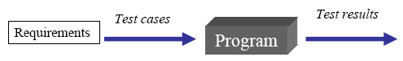
- equivalence partitioning

Black-box testing
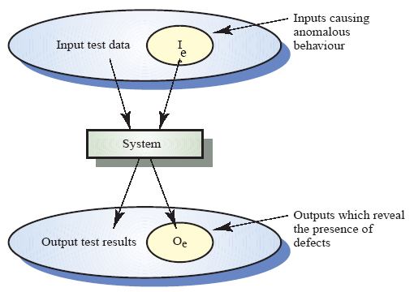
(inconsistent / unusual / irregular)

White-box
• Sometimes called Structural testing or glass box testing
• Derivation of test cases according to program structure. Knowledge of the program used to identify additional test cases
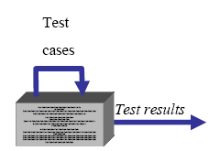
• Objective is to exercise all program statements (not all path combinations)

Structural testing
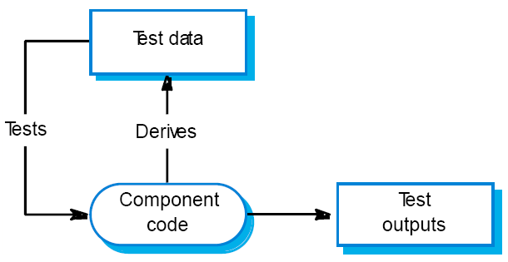

Software Inspection
• Inspection techniques include,
– Program inspections
– Automated source code analysis
– Formal verification
• Can only check the correspondence between a program and its specification (verification)
• Unable to demonstrate that the software is operationally useful.
• Can not check non-functional requirements (performance, reliability)
• Inspections not require execution of a system so may be used before implementation.
• They have been shown to be an effective technique for discovering program errors.
– Many different defects may be discovered in a single inspection. In testing, one defect, may mask another so several executions are required.
– The reuse domain and programming knowledge so reviewers are likely to have seen the types of error that commonly arise.
Program Inspections
• Formalized approach to document reviews
• Intended explicitly for defect detection (not correction).
• Defects may be logical errors, anomalies in the code that might indicate an erroneous condition (e.g. an uninitialised variable) or non-compliance with standards.
Inspection Roles
Author or owner The programmer or designer responsible for producing the program or document. Responsible for fixing defects discovered during the inspection process.
Inspector Finds errors, omissions and inconsistencies in programs and documents. May also identify
broader issues that are outside the scope of the inspection team.
Reader Presents the code or document at an inspection meeting.
Scribe Records the results of the inspection meeting.
Chairman or moderator Manages the process and facilitates the inspection. Reports process results to the Chief moderator.
Chief moderator Responsible for inspection process improvements, checklist updating, standards development etc.
Inspection Pre-conditions
• A precise specification must be available.
• Team members must be familiar with the organization standards.
• Syntactically correct code or other system representations must be available.
• An error checklist should be prepared.
• Management must accept that inspection will increase costs early in the software process.
• Management should not use inspections for staff appraisal ie finding out who makes mistakes.
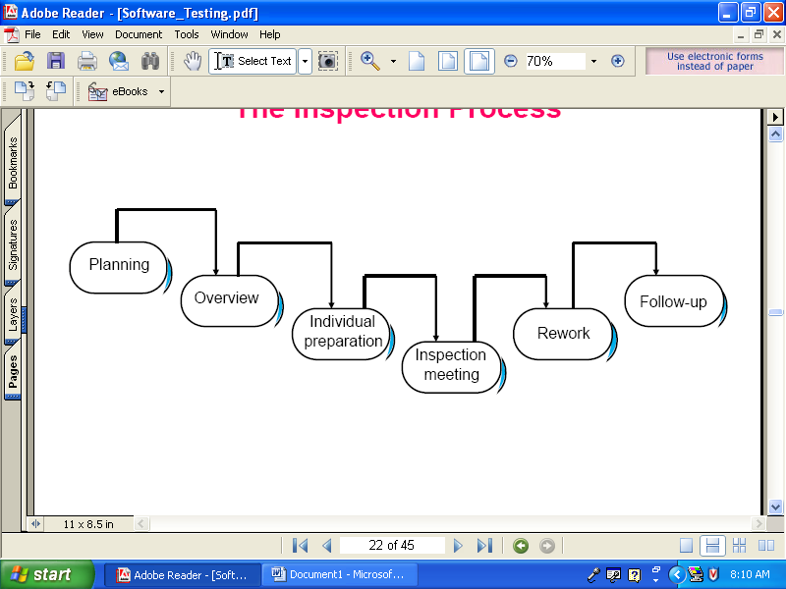
The Inspection Process

The Inspection Process
• System overview presented to inspection team.
• Code and associated documents are distributed to inspection team in advance.
• Inspection takes place and discovered errors are noted.
• Modifications are made to repair discovered errors.
• Re-inspection may or may not be required.
Inspection Checks
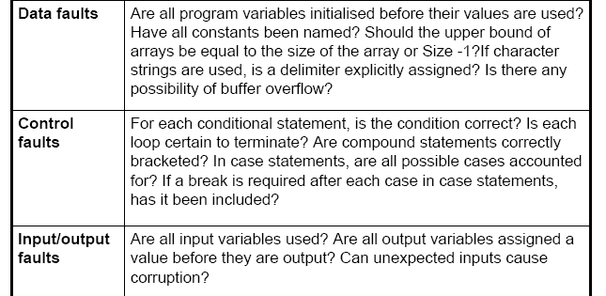

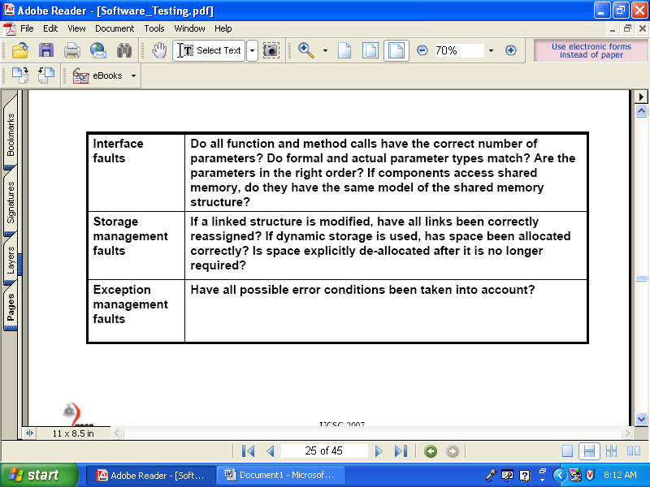

6.3. Levels of testing

Test Phases

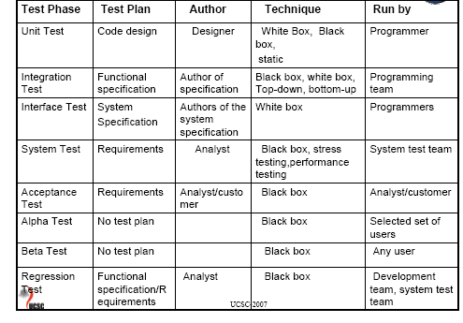

Unit Testing
Unit Testing is carried out as a part of the coding task. This phase is based on the design of the software for a piece of code. Unit testing should prove the following about the code
• Robust – the code should not fail under any circumstances.
• Functionally correct – the code should carry out the task defined by the code design
• Correct interface – the inputs and outputs from the code should be as defined in the design
Unit Test Plan –
The unit test plan must be based on the design of the code and not the code itself.
Therefore, the test plan will be written after the completion of design but before the start of the coding phase.
The test plan is the responsibility of the designer of the code. The testing is usually carried out by the author of the code.
Integration/Sub-systems Testing
Integration Testing is carried out after the separate software modules have been unit testing. Integration testing is based on the functional specification of the software.
Integration testing should prove the following about the software:
Integration - the modules of the system should interact as designed.
Functionally correct - the system should behave as defined in the functional specification
Integration test plan –
This is based on the specification of the system. The test plan is usually written by the authors of the system specification to avoid any assumptions made during design from being incorporated into the test plan.
Incremental Integration Testing
Initially, integrate a minimal system configuration and test the system. Then add components to this minimal configuration and test after each added increment.

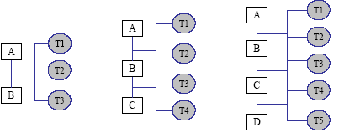

T1,T2 and T3 tests are carried out after integration of components A and B. If the tests are successful, add C and carry out tests T1, T2,T3 and T4. If new errors introduced, that is due to the integration of C.
Top-Down Integration Testing
In top-down integration, the high-level components of a system are integrated and tested before design and implementation of some of the high-level components has been completed.
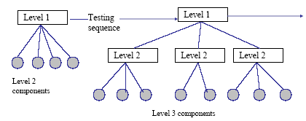

Bottom-up Integration Testing
Low-level components are integrated and tested before the higher-level components have been developed.
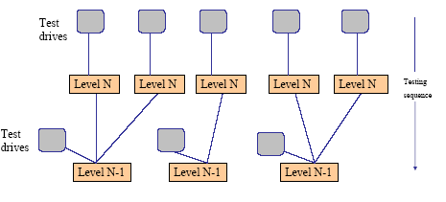

Interface Testing
• Interface testing takes place when modules or subsystems are integrated to create large systems.
• Each module or sub-system has a defined interface which is called by other program components.
• Objectives are to detect faults due to interface errors or invalid assumptions about interfaces.
• Particularly important for object-oriented development as objects are defined by their interfaces.
• Cannot be detected by testing the individual objects.
– The errors will occur due to the interaction between objects.
Types of Interfaces
• Parameter Interfaces- These are interfaces where the data or sometimes function references are passed from one component to another.
• Shared memory Interfaces-These are interfaces where block of memory is shared between sub-systems. Data is placed in memory by one sub-system and retrieved from there by other sub-system.
• Message passing Interfaces- These are interfaces where one subsystem request a service from another sub-system by passing a message to it.
• Procedural Interfaces- These are interfaces where one sub-system encapsulates a set of procedures which can be called by other subsystem. Objects and abstract data types have this form of interface.
System Testing
System testing is carried out at the completion of the integration testing. The purpose of system testing is to prove that the software meets the agreed user requirements and works in the target environment. System testing covers both functional and non-functional requirements.
System Test Plan-
The system test plan is based around the agreed requirements.Test plan covers functional requirements and non-functional requirements such as performance.
The system test plan is written by the author of the requirements document to avoid assumption introduced during specification. The system test plan will also include tests to cover
• Recovery – Force the system to crash and then try to recover to a sensible state.
• Security – Attempt to access the system without the correct authority, or attempt to carry out restricted functions.
• Stress - Attempt to break the system by overloading it.
• Performance- Ensure the system meets the performance requirements.
Acceptance Testing
Acceptance testing is carried out at the customers site with the customer in attendance. The purpose of the acceptance test is to show to the customer that the software does indeed work. These tests are usually a sub set of the system test.
Acceptance test plan –
This should be agreed with the customer after the requirements for the software have been agreed. Sometimes the customer will write the test plan in which case it must be agreed with the software developers.
Alpha, Beta and Regression Testing
Alpha Testing –
Alpha testing is the first real use of the software product. Having completed system testing the product will be given to a small number of selected customers or possible just distributed within the company itself. The software will be used
‘in anger’ and errors reported to the development and maintenance team.
Beta Testing –
After alpha testing has been completed and any changes made a new version of the product will be released to much wider audience. The objective of Beta testing is to iron out the remaining problems with the product before it is put on the general release.
Regression Testing –
Regression testing carried out after any changes are made to a software application. The purpose of regression test is to prove that the change has been made correctly and that the change has not introduced any new errors.
Regression test plans are usually a sub-set of the integration or systems test plans. It is designed to cover enough functionality to give confidence that the change has not effected any other part of the system.
Back-to-back testing and Thread testing
Back-to-back testing
Back-to-back testing means that multiple versions of the software are executed on the same test data. If they all agree on the answer, it is assumed that they are all correct.
Thread testing
Based on testing an operation which involves a sequence of processing steps which thread their way through the system
Start with single event threads then go on to multiple event threads
Advantages
Suitable for real-time and object-oriented systems
Disadvantage
Difficult to assess test adequacy, because of large number of event combinations
Statistical Software Testing
• Statistical testing involves exercising a program with generated random inputs, the test profile and the number of generated inputs being determined according to criteria based on program structure or software functionality. In case of complex programs, the probabilistic generation must be based on a black box analysis, the adopted criteria being defined from behavior models deduced from the specification.
Object Oriented Testing
In an object oriented system, four levels of testing can be identified:
1. Testing the individual operations associated with objects – These are functions or procedures and the black-box and white-box approaches may be used.
2. Testing individual object classes – The principle of black-box testing is unchanged but the notion of an equivalence class must be extended to cover related operation sequences.
3. Testing clusters of objects - Strict top-down or bottom-up integration may be inappropriate to create groups of related objects. Other approaches such as scenario based testing should be used.
4. Testing the object oriented system - V & V against the systems requirements specification is carried out in exactly the same way as for any other type of system.
Object Class Testing
When testing objects, complete test coverage should include:
1. the testing in isolation of all operations associated with the object;
2. the setting and interrogation of all attributes associated with the object;
3. the exercise of the object in all possible states. This means that all events that cause a state change in the object should be simulated.
Object Integration
In object oriented systems, there is no obvious ‘top’ that provides for the integration nor is there a clear hierarchy of objects that can be created. Clusters therefore have to be created using knowledge of there operation and the features of the system that are implemented by these clusters. There are three possible approaches to integration testing that may be used:
1. Use-case or scenario- based testing – Testing can be based on the
scenario descriptions and object clusters created to support the use-cases that
relate to that mode of use.
2. Thread testing – Thread testing is based on testing the system’s response to a particular input or set of input events.
3. Object interaction testing – An intermediate level of integration testing can be based on identifying ‘method – message’ paths. These are traces through a sequence of object interactions which stop when an object operation does not call on the services of any other object.
Design of Test Cases
• Test case design is a part of system and component testing.
• The objective of the test case designing process is to develop test cases.
• These test cases are used to detect program defects and also it detects whether the system meets its requirements.
• When designing a test case,
– select a particular feature of the system.
– Select set of inputs that execute that feature.
– Decide possible outputs of the test case.
– Check the difference between actual and the expected out comes after the testing procedure.
Test case designing approaches
• Requirements-based testing-Test cases are designed to test the system requirements. Mostly used at the system testing stage. Test cases should be created for each requirement to verify that the system meets requirements.
• Partition testing-Identify input and output partitions. The system executes inputs from all partitions.
• Structural testing- Use the knowledge of program structure to design tests that exercise all parts of the program. When testing a program, each statement should be executed at least once.

